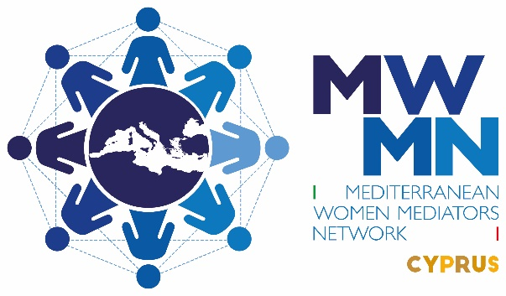

Press Statement by the Mediterranean Women Mediators Network/CYPRUS ANTENNA

The Concept of Security from a Feminist Perspective

In the last twenty years since the unanimous adoption of resolution 1325 by the United Nations Security Council we have seen a plethora of writings and much discussion on what constitutes ‘security’ from a women’s and feminist perspective. Here in Cyprus, living for decades in a protracted ethnonational conflict and divided society, security has always been one of the basic human needs for both communities. It was often referred to that the security of one community, as defined by political elites, constitutes insecurity for the other. In the decades’ old and male- dominated peace negotiations security has been discussed from the perspective of territory, legal and military aspects based on the 1960 treaty of Guarantees. This is the state-centered understanding of security which refers to ‘hard politics’ that is, it deals with state borders, percentages of territory, defense budgets for military needs, war systems and superiority over other states. Instead, the feminist understanding of security deals with ‘soft holistic politics’ and it is human-centered and addresses the everyday life of people. The United Nations Organization first used the concept of ‘Human Security’ in 1997, and since 2012 it has included Human Development, Human Rights-social, political, cultural, psychological and economic. The feminist approach to Human Security draws attention to gender, in addition to the systematic exclusion of women and women’s interests and needs from the corridors of power and allocation of funds in areas of health, education, the clean environment, legal guarantees for gender equality and programs for the elimination of all kinds of violences - from the domestic, to the international.

Thus a feminist approach to security reinforces the right of women, girls, minorities, refugees, trafficked persons and people with disabilities to live in freedom and dignity, free from hunger and desperation and multiple oppressions due to patriarchal regimes. Thus, as feminists, we support the empowerment and protection of women and all disadvantaged and vulnerable groups from discrimination, exclusion, marginalization, and exploitation.

Feminists believe that the instrumental use of the past and the constant focus on the ‘barbarism’ of the other and the reference exclusively and selectively to painful and traumatic past events and memories reinforce the feelings of insecurity and violate the right to Human Security. This policy has been often used in our societies by the state, the institutions of education, the communication media, political parties, the church and others. In addition, this constant blaming and polarization violates people’s right to live free of fear and intolerance. This right relates to the feminist perspective of ethical and responsible care which is both the obligation of the state, international organizations and civil society. As we enter the resumption of peace processes, we invite our leaders and political elites and all stake holders to pay equal attention to Human Security from a holistic feminist perspective and to women’s needs and struggles at the grass roots.

Imagine what we could have achieved if we had made as much progress in building a global security structure based on feminine principles of cooperation, human security, gender equality, pragmatism, transparency, inclusivity, intersectionality as well as a redefinition of power which invites states and societies to do things together for a peaceful world for all.

On behalf of the Mediterranean Women Mediators Network/CYPRUS ANTENNA
Dr. Maria Hadjipavlou, one of the founding members
mariat@ucy.ac.cy
99-305283

